**TICKETS**

**$47**

**\***

**\*plus fees**

**Reserved Seating**

**Friday,**

**August 16**

**8:00**

**PM**

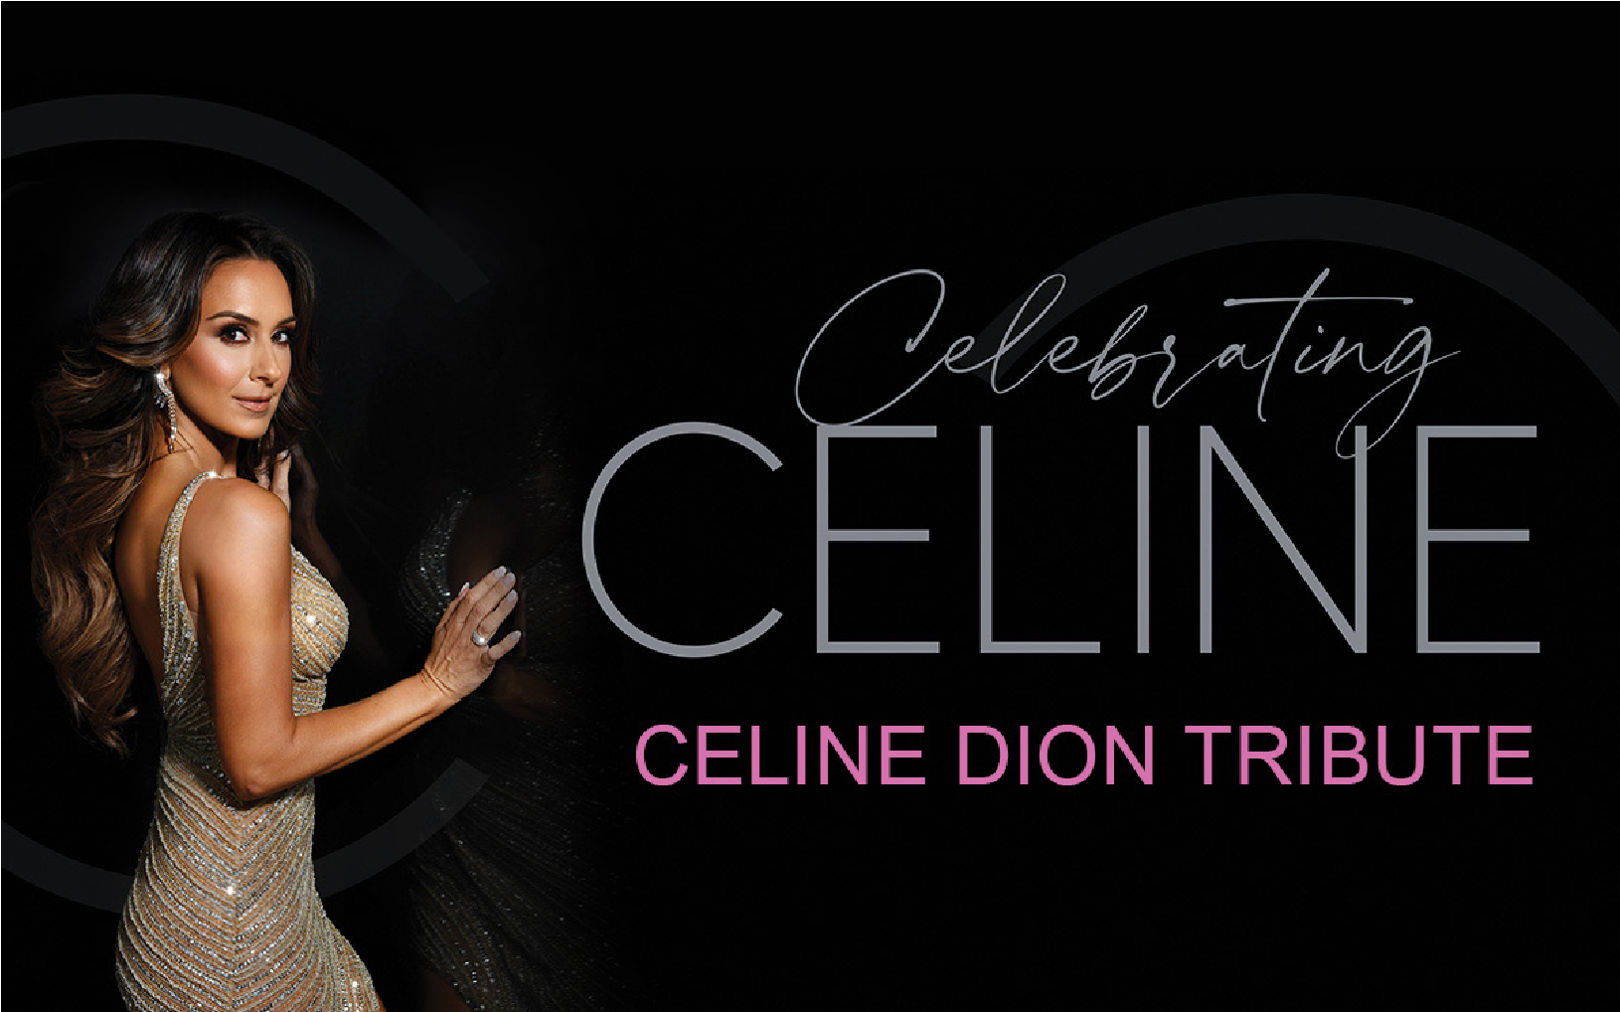

**Jenene Caramielo delivers a premier musical tribute to Celine Dion. Be amazed as she effortlessly recreates Celine’s iconic power ballads such as “*My Heart Will Go On*,” “*It’s All Coming Back to Me Now,*” “*Because You Loved Me*” and many more.**

*The Foster Kids of the Merrimack Valley is dedicated to serving the needs of foster children in the Merrimack Valley with a goal to bring a positive influence into their lives and provide programs that support the children as they grow.*



PRESENTS

A BENEFIT CONCERT

**978.462.5888 | www.BlueOceanHall.com**

**4 Ocean Front North | Salisbury Beach MA 01952**

**Box Office Hours: Mon-Sat 11:30AM-7PM, Sun 10AM-5PM**